Software Design Document

for

MyTax

Version 1.0

Prepared by:

Francisco Aguirre

Gustavo Montes

Jose Carlos Martinez

Jorge Origel

Benjamin Villegas

**TABLE OF CONTENTS**

1. INTRODUCTION 2

1.3 Overview 2

1.4 Reference Material 2

1.5 Definitions and Acronyms 2

2. SYSTEM OVERVIEW 2

3. SYSTEM ARCHITECTURE 2

3.2 Decomposition Description 3

3.3 Design Rationale 3

4. DATA DESIGN 3

4.2 Data Dictionary 3

5. COMPONENT DESIGN 3

6. HUMAN INTERFACE DESIGN 4

6.2 Screen Images 4

6.3 Screen Objects and Actions 4

7. REQUIREMENTS MATRIX 4

8. APPENDICES 4

Revision History

|  |  |  |  |
| --- | --- | --- | --- |
| **Name** | **Date** | **Reason For Changes** | **Version** |
| Francisco Aguirre  Gustavo Montes  Jose Carlos Martinez  Jorge Origel  Benjamin Villegas | 18-Oct-13 | Initial Version | 1.0 |
|  |  |  |  |

### INTRODUCTION

* 1. **Purpose**

Identify the purpose of this SDD and its intended audience. (e.g. “This software design document describes the architecture and system design of XX. ….”).

* 1. **Scope**

Provide a description and scope of the software and explain the goals, objectives and benefits of your project. This will provide the basis for the brief description of your product.

## Overview

Provide an overview of this document and its organization.

## Reference Material

*This section is optional.*

List any documents, if any, which were used as sources of information for the test plan.

## Definitions and Acronyms

*This section is optional.*

Provide definitions of all terms, acronyms, and abbreviations that might exist to properly interpret the SDD. These definitions should be items used in the SDD that are most likely not known to the audience.

### SYSTEM OVERVIEW

Give a general description of the functionality, context and design of your project. Provide any background information if necessary.

### SYSTEM ARCHITECTURE

* 1. **Architectural Design**

Develop a modular program structure and explain the relationships between the modules to achieve the complete functionality of the system. This is a high level overview of how

responsibilities of the system were partitioned and then assigned to subsystems. Identify each high level subsystem and the roles or responsibilities assigned to it. Describe how these subsystems collaborate with each other in order to achieve the desired functionality. Don’t go into too much detail about the individual subsystems. The main purpose is to gain a general understanding of how and why the system was decomposed, and how the individual parts work together. Provide a diagram showing the major subsystems and data repositories and their interconnections. Describe the diagram if required.

## Decomposition Description

Provide a decomposition of the subsystems in the architectural design. Supplement with text as needed. You may choose to give a functional description or an object­oriented description. For a functional description, put top­level data flow diagram (DFD) and structural decomposition diagrams. For an OO description, put subsystem model, object diagrams, generalization hierarchy diagram(s) (if any), aggregation hierarchy diagram(s) (if any), interface specifications, and sequence diagrams here.

## Design Rationale

Discuss the rationale for selecting the architecture described in 3.1 including critical issues and trade/offs that were considered. You may discuss other architectures that were considered, provided that you explain why you didn’t choose them.

### DATA DESIGN

* 1. **Data Management**

**DES-4.1.1** - System uses a SQLITE Local database to store data entered by the user in the Mobile Device. (REQ- 3.1.2.4)

**DES-4.1.2** - System uses a SQLITE Local database to store SAT regulations in the Mobile Device. (REQ- 3.1.2.4)

**DES-4.1.3**: Remote Server uses a SQLITE Local database to store SAT regulations. (REQ-3.4.2.2)

**DES-4.1.4**: My Tax team use SQLITE Database Browser V 2.01 to update SAT regulation in the remote server. (REQ-3.4.2.1)

## Data Model

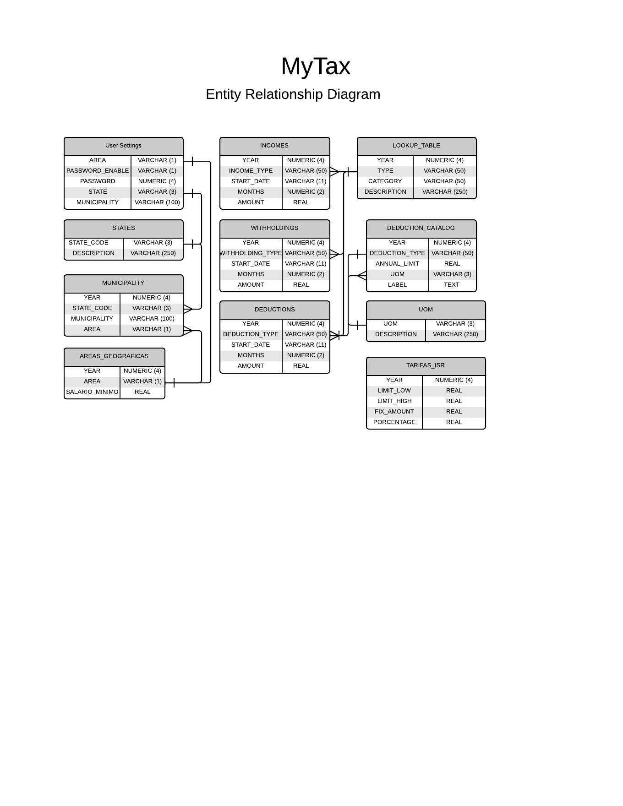

## Scripts

## --------------------------------------------------------------------------------

## CREATE TABLE USER_SETTINGS

## (

## AREA VARCHAR (1) NOT NULL,

## PASSWORD_ENABLE VARCHAR (1) NOT NULL,

## PASSWORD NUMERIC (4) NOT NULL,

## STATE VARCHAR (3) NOT NULL,

## MUNICIPALITY VARCHAR (100) NOT NULL

## );

## --------------------------------------------------------------------------------

## CREATE TABLE AREAS_GEOGRAFICAS

## (

## YEAR NUMERIC (4) NOT NULL,

## AREA VARCHAR (1) NOT NULL,

## SALARIO_MINIMO REAL NOT NULL,

## PRIMARY KEY (YEAR, AREA)

## );

## --------------------------------------------------------------------------------

## CREATE TABLE STATES

## (

## STATE_CODE VARCHAR (3) NOT NULL,

## DESCRIPTION VARCHAR (250) NOT NULL,

## PRIMARY KEY (STATE_CODE)

## );

## --------------------------------------------------------------------------------

## CREATE TABLE MUNICIPALITY

## (

## YEAR NUMERIC (4) NOT NULL,

## STATE_CODE VARCHAR (3) NOT NULL,

## MUNICIPALITY VARCHAR (100) NOT NULL,

## AREA VARCHAR (1),

## PRIMARY KEY (YEAR, STATE_CODE, MUNICIPALITY)

## );

## --------------------------------------------------------------------------------

## CREATE TABLE UOM

## (

## UOM VARCHAR (3) NOT NULL,

## DESCRIPTION VARCHAR (250) NOT NULL,

## PRIMARY KEY (UOM)

## );

## --------------------------------------------------------------------------------

## CREATE TABLE TARIFAS_ISR

## (

## YEAR NUMERIC (4) NOT NULL,

## LIMIT_LOW REAL NOT NULL,

## LIMIT_HIGH REAL NOT NULL,

## FIX_AMOUNT REAL NOT NULL,

## PORCENTAGE REAL NOT NULL

## );

## --------------------------------------------------------------------------------

## CREATE TABLE LOOKUP_TABLE

## (

## YEAR NUMERIC (4) NOT NULL,

## TYPE VARCHAR (50) NOT NULL,

## CATEGORY VARCHAR (50) NOT NULL,

## DESCRIPTION VARCHAR (250) NOT NULL,

## PRIMARY KEY (YEAR, TYPE, CATEGORY)

## );

## --------------------------------------------------------------------------------

## CREATE TABLE DEDUCTION_CATALOG

## (

## YEAR NUMERIC (4) NOT NULL,

## DEDUCTION_TYPE VARCHAR (50) NOT NULL,

## ANNUAL_LIMIT REAL NOT NULL,

## UOM VARCHAR (3) NOT NULL,

## LABEL TEXT ,

## PRIMARY KEY (YEAR, DEDUCTION_TYPE)

## 

## );

## --------------------------------------------------------------------------------

## CREATE TABLE WITHHOLDINGS

## (

## _ID INTEGER PRIMARY KEY,

## YEAR NUMERIC (4) NOT NULL,

## WITHHOLDING_TYPE VARCHAR (50) NOT NULL,

## START_DATE VARCHAR (11) NOT NULL,

## MONTHS NUMERIC (2) NOT NULL,

## AMOUNT REAL NOT NULL

## );

## --------------------------------------------------------------------------------

## CREATE TABLE INCOMES

## (

## _ID INTEGER PRIMARY KEY,

## YEAR NUMERIC (4) NOT NULL,

## INCOME_TYPE VARCHAR (50) NOT NULL,

## START_DATE VARCHAR (11) NOT NULL,

## MONTHS NUMERIC (2) NOT NULL,

## AMOUNT REAL NOT NULL

## );

## --------------------------------------------------------------------------------

## CREATE TABLE DEDUCTIONS

## (

## _ID INTEGER PRIMARY KEY,

## YEAR NUMERIC (4) NOT NULL,

## DEDUCTION_TYPE VARCHAR (50) NOT NULL,

## START_DATE VARCHAR (11) NOT NULL,

## MONTHS NUMERIC (2) NOT NULL,

## AMOUNT REAL NOT NULL

## );

### COMPONENT DESIGN

In this section, we take a closer look at what each component does in a more systematic way. If you gave a functional description in section 3.2, provide a summary of your algorithm for each function listed in 3.2 in procedural description language (PDL) or pseudocode. If you gave an OO description, summarize each object member function for all the objects listed in 3.2 in PDL or pseudocode. Describe any local data when necessary.

### HUMAN INTERFACE DESIGN

* 1. **Overview of User Interface**

Prototype:[*https://moqups.com/villegasben/XmAbEqOz/*](https://moqups.com/villegasben/XmAbEqOz/)

Using Android SDK 4.0+ and Android Development Tools for Eclipse create UI for:

**DES-6.1.1**: Account setup page. (REQ 4.1.1)

**DES-6.1.2**: Page with SAT regulation guide for a fiscal Year. (REQ 4.1.2)

**DES-6.1.3**: Page to enter deductions.( REQ 4.1.3)

**DES-6.1.4**: Page to enter withholding. (REQ 4.1.4)

**DES-6.1.5**: Page to enter incomes. (REQ 4.1.5)

**DES-6.1.6**: Page to calculate ISR Taxes with deductions. (REQ 4.1.6)

**DES-6.1.7**: Page to calculate ISR Taxes without deductions.(REQ 4.1.7)

## Screen Images

## 

**DES-6.1.1:** Account setup page

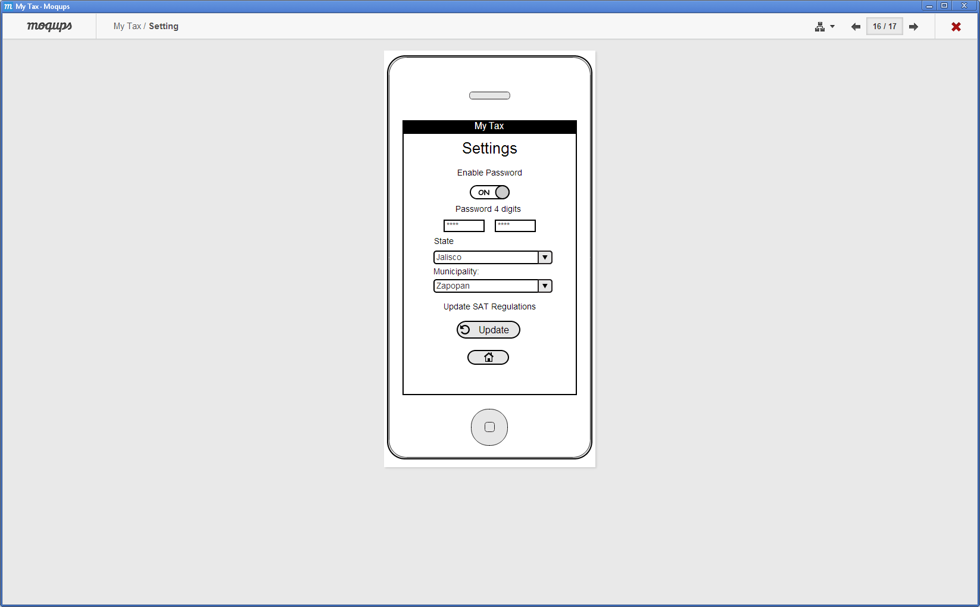

**DES-6.1.2:** Page with SAT regulation guide for a fiscal Year

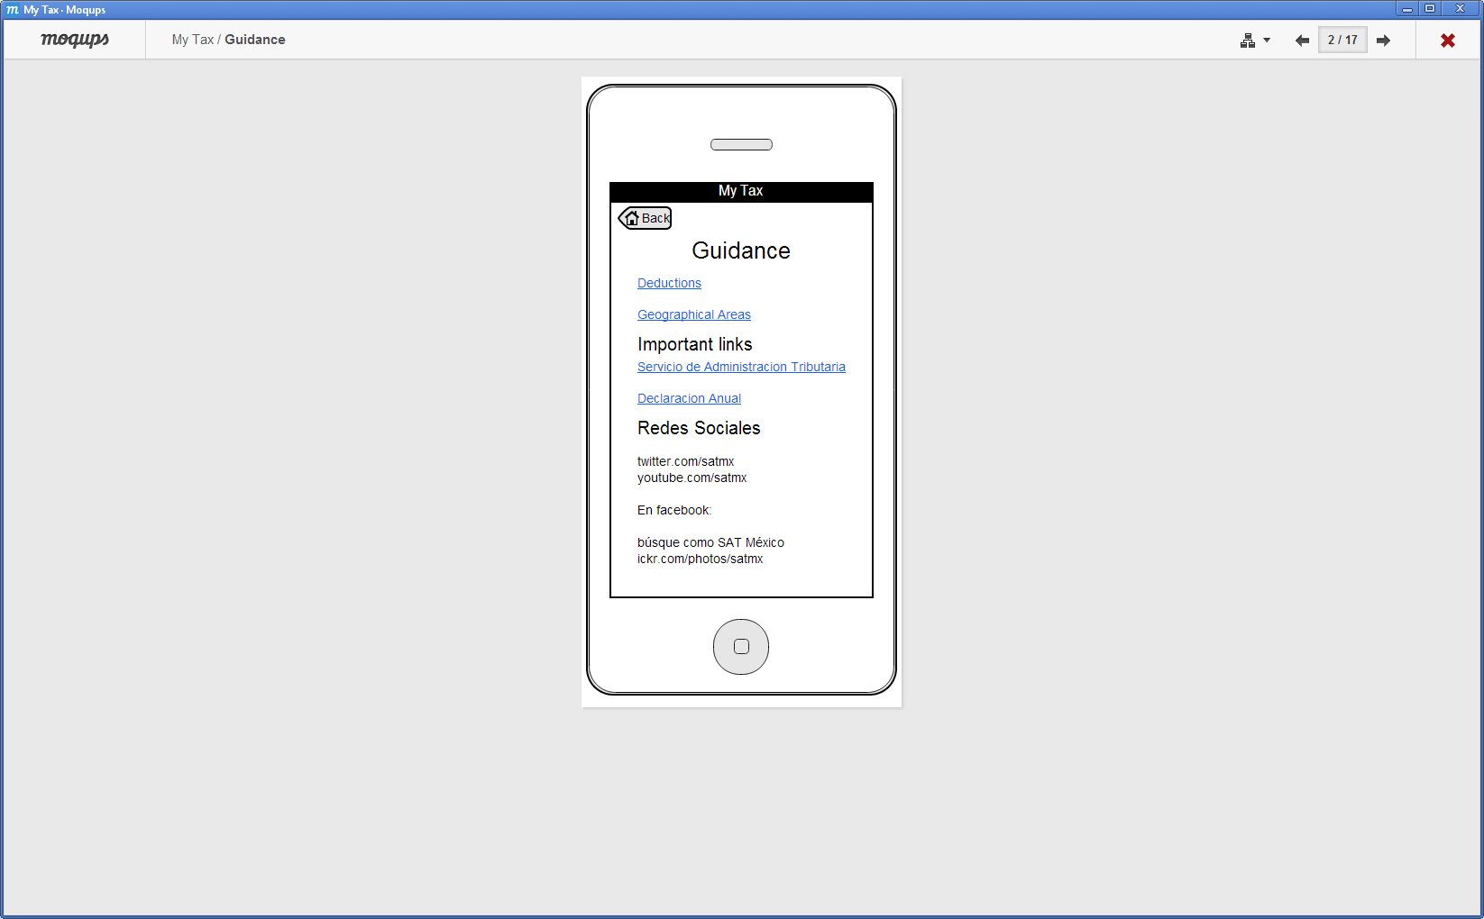 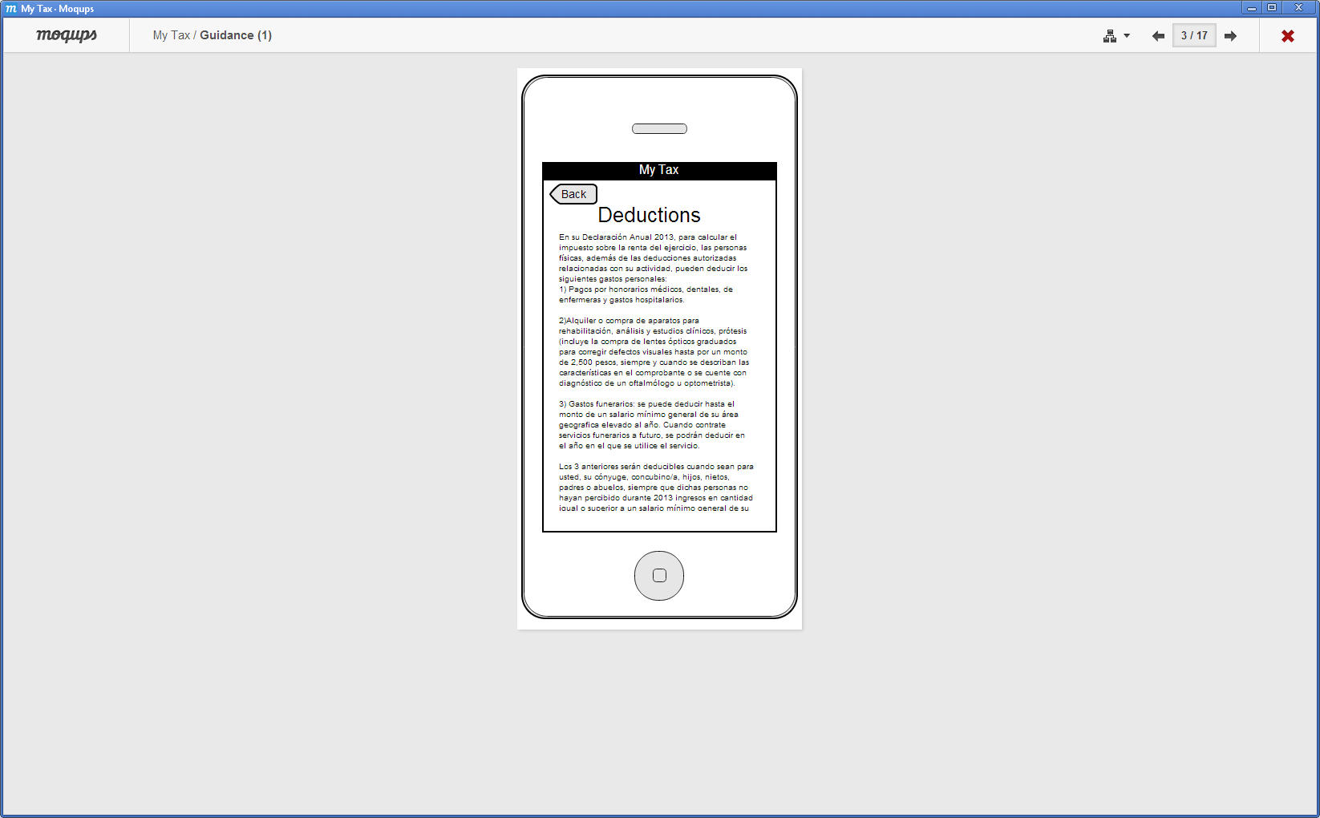 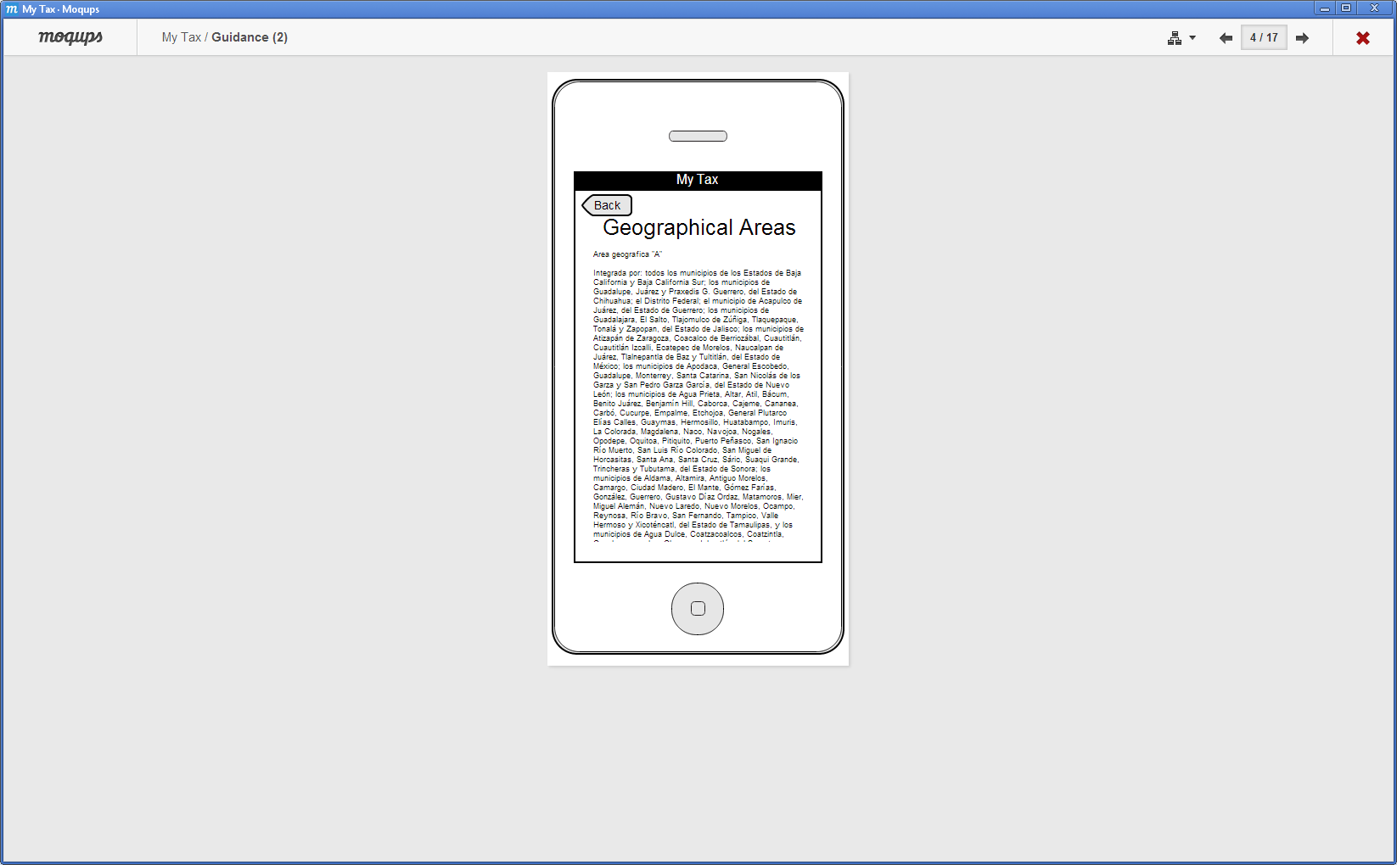

**DES-6.1.3:** Page to enter deductions.

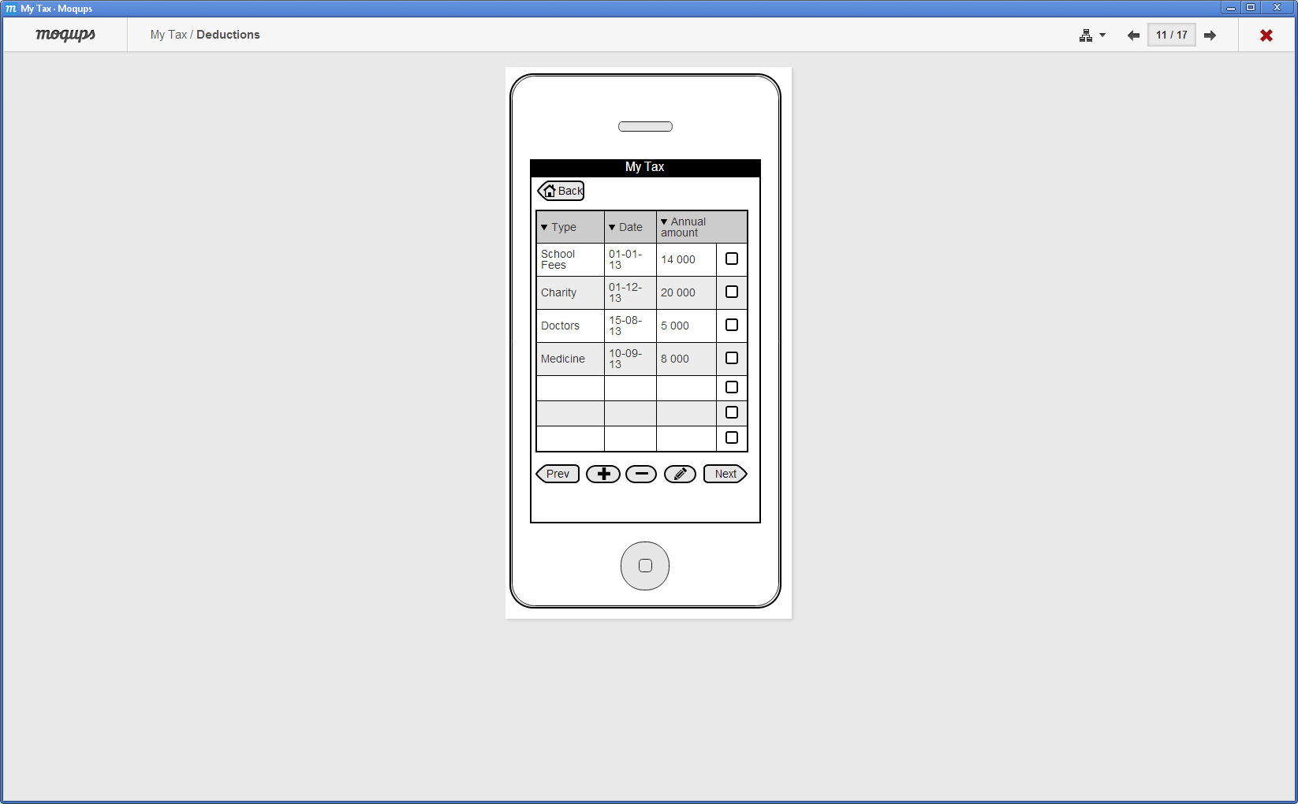 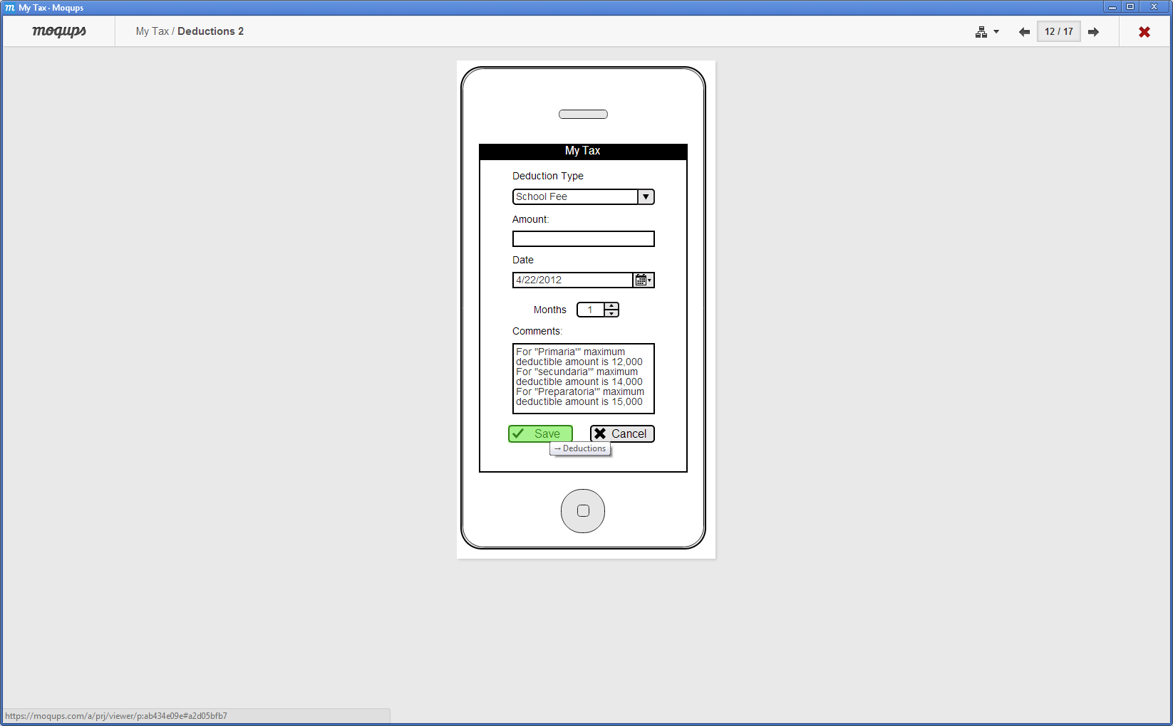

**DES-6.1.4:** Page to enter withholding.

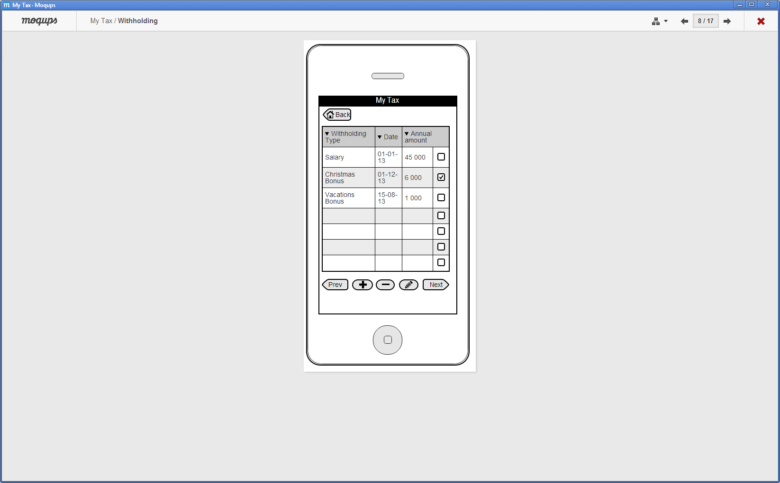 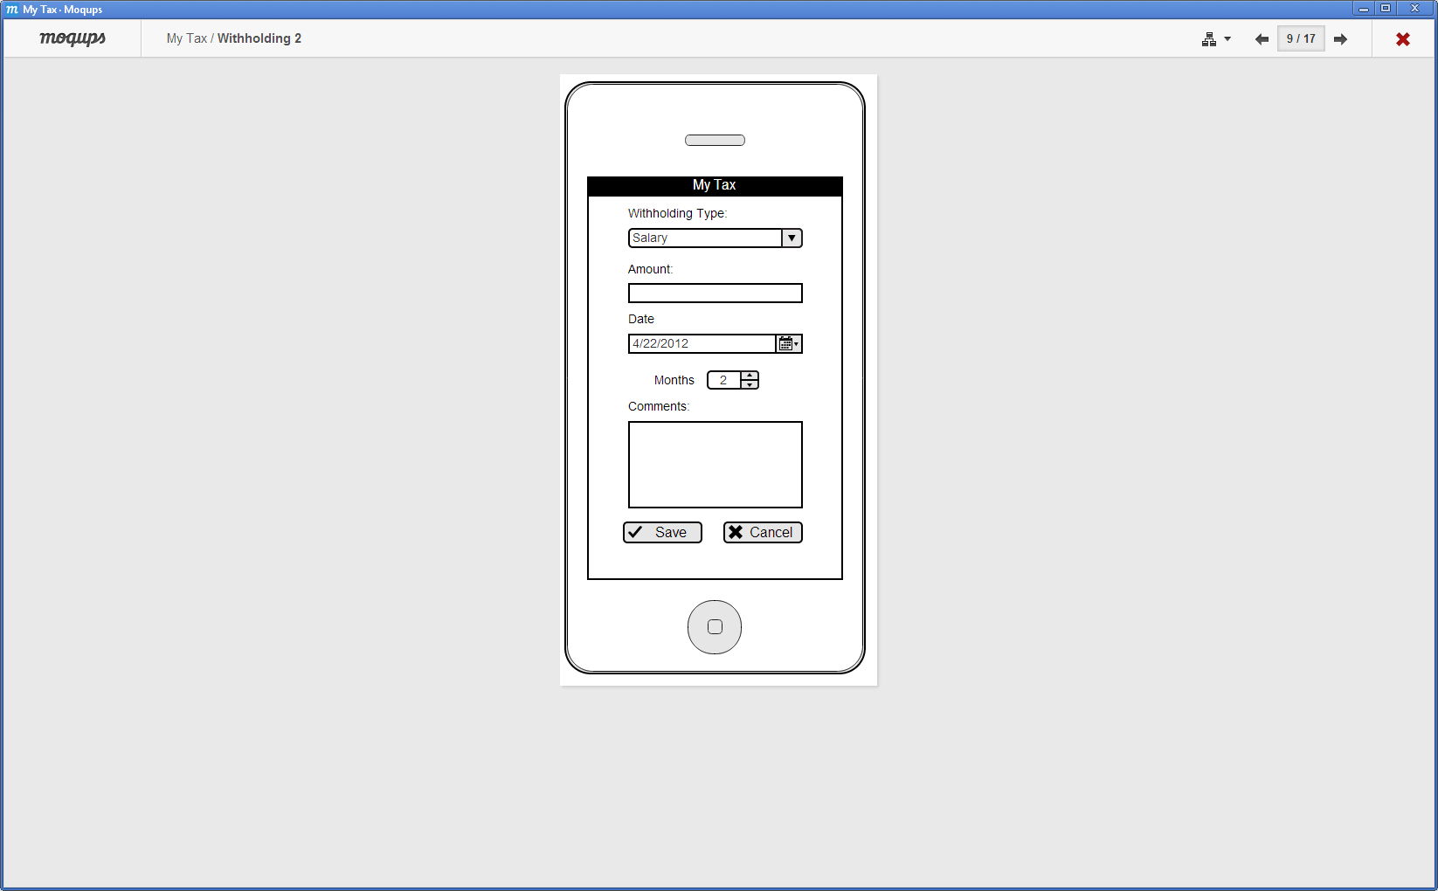

**DES-6.1.5:** Page to enter incomes.

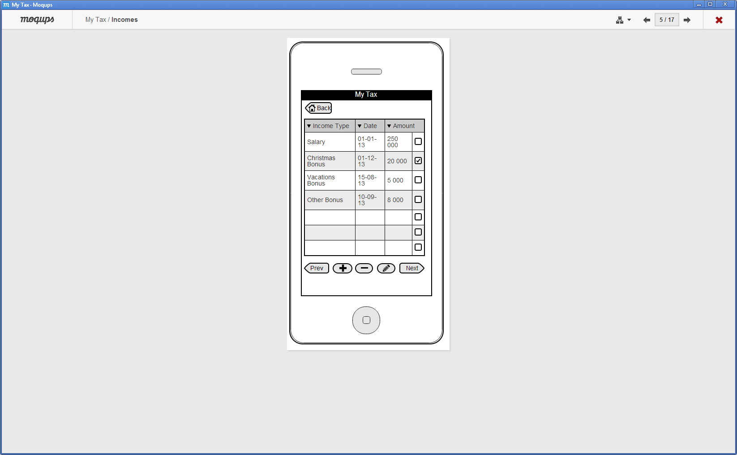 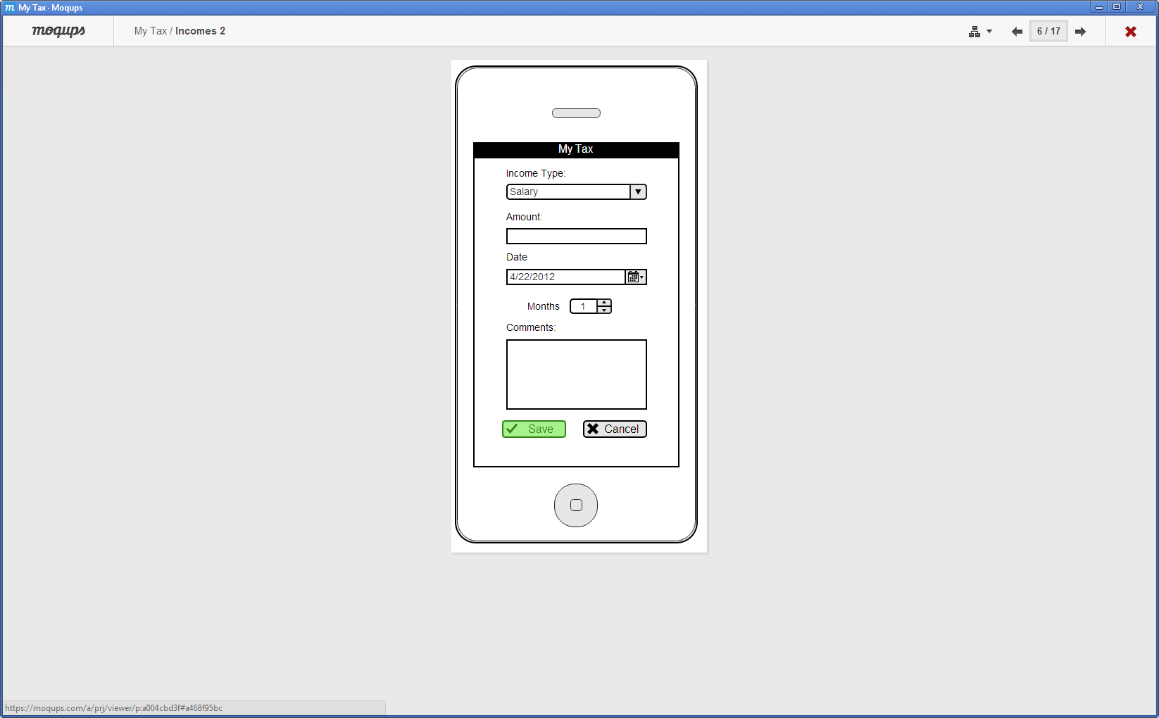

**DES-6.1.6:** Page to calculate ISR Taxes with deductions.

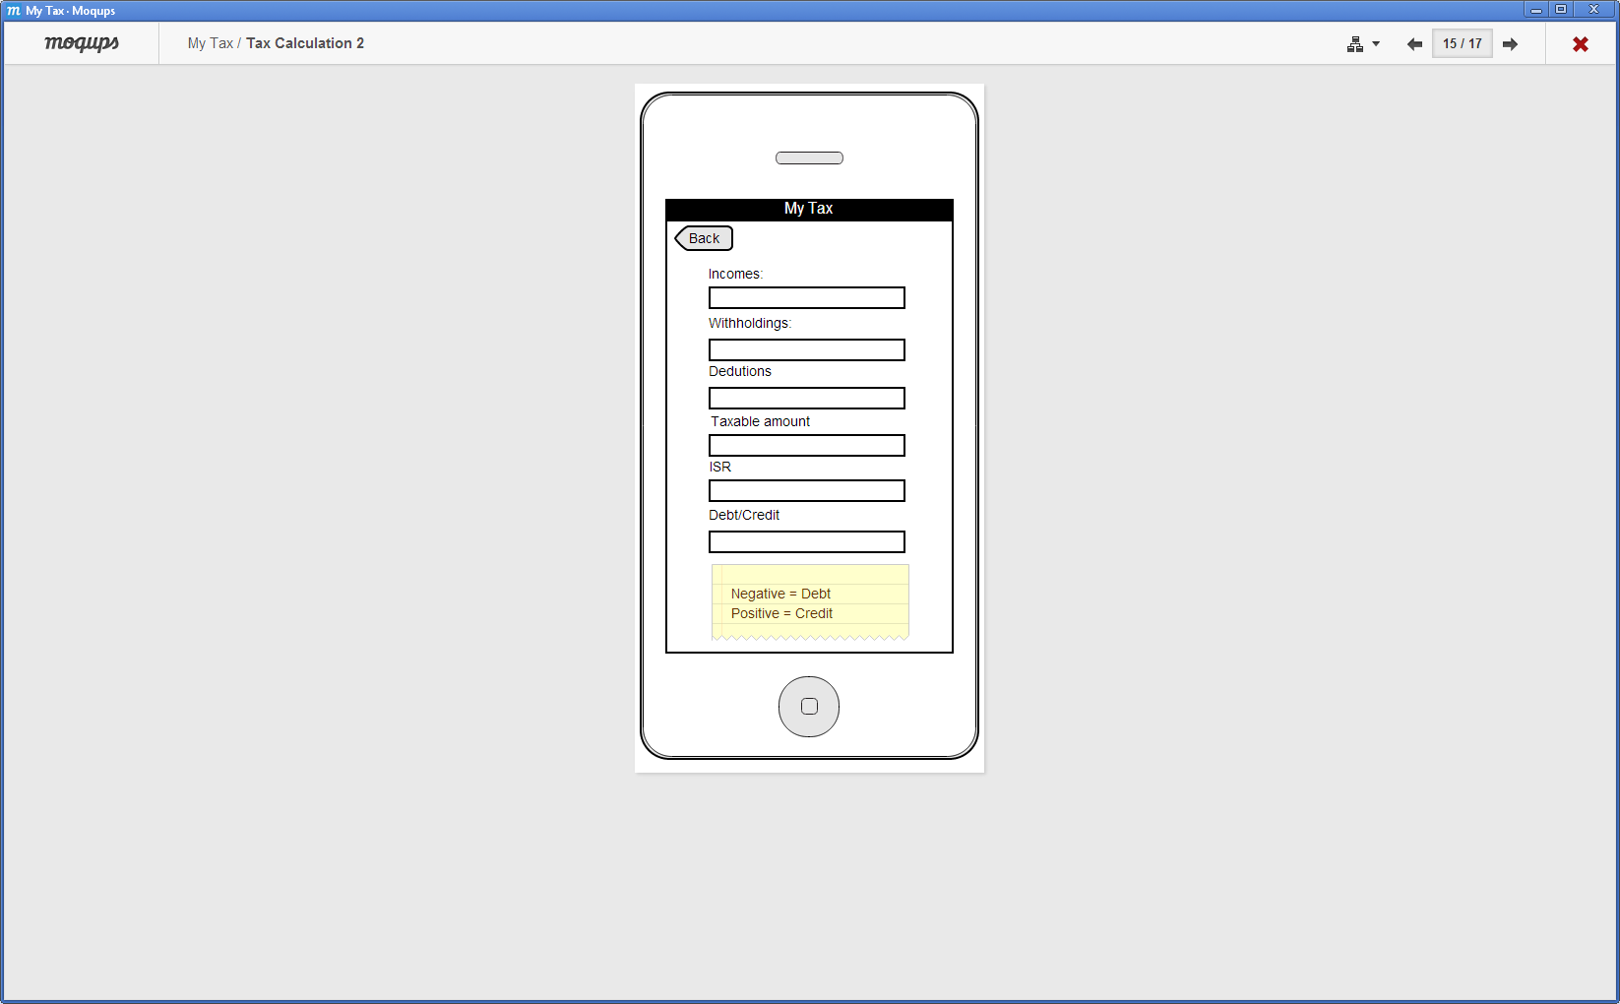

**DES-6.1.7:** Page to calculate ISR Taxes without deductions.

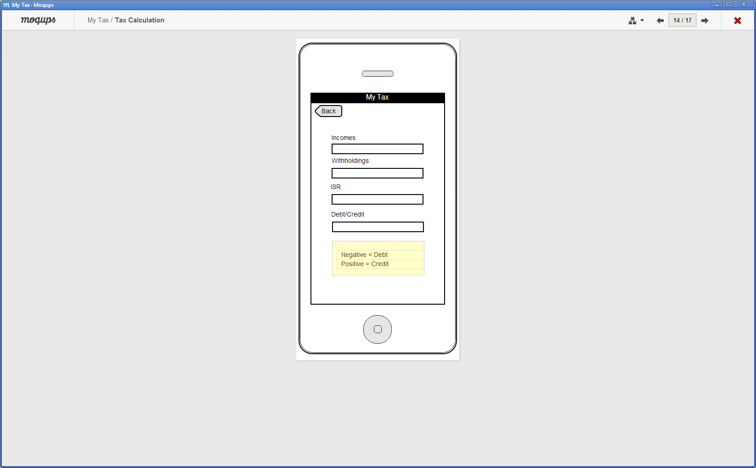

## Screen Objects and Actions

**DES-6.3.1:** Selecting **DES-6.1.6:** Page to calculate ISR Taxes with deductions and **DES-6.1.7:** Page to calculate ISR Taxes without deductions; triggers the calculation process:

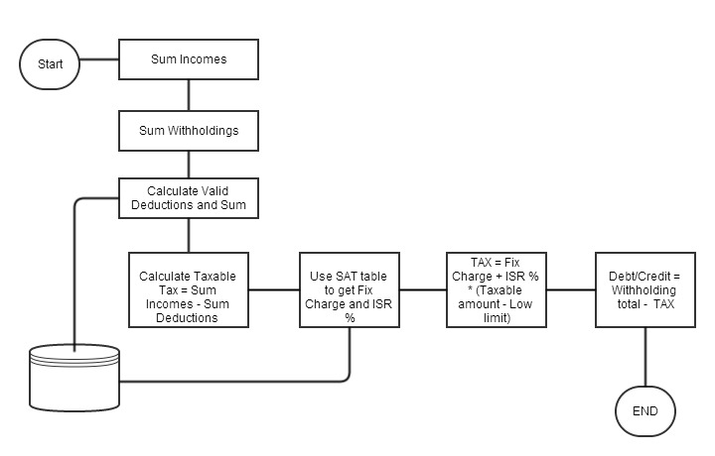

### REQUIREMENTS MATRIX

| **Solution design** | **Description** | **Requirement** |
| --- | --- | --- |
| DES-4.1.1 | System uses a SQLITE Local database to store data entered by the user in the Mobile Device | REQ- 3.1.2.4 |
| DES-4.1.2 | System uses a SQLITE Local database to store SAT regulations in the Mobile Device | REQ- 3.1.2.4 |
| DES-4.1.3 | Remote Server uses a SQLITE Local database to store SAT regulations | REQ-3.4.2.2 |
| DES-4.1.4 | My Tax team use SQLITE Database Browser V 2.01 to update SAT regulation in the remote server | REQ-3.4.2.1 |
| DES-6.1.1 | Account setup page | REQ 4.1.1 |
| DES-6.1.2 | Page with SAT regulation guide for a fiscal Year | REQ 4.1.2 |
| DES-6.1.3 | Page to enter deductions | REQ 4.1.3 |
| DES-6.1.4 | Page to enter withholding | REQ 4.1.4 |
| DES-6.1.5 | Page to enter incomes | REQ 4.1.5 |
| DES-6.1.6 | Page to calculate ISR Taxes with deductions | REQ 4.1.6 |
| DES-6.1.7 | Page to calculate ISR Taxes without deductions | REQ 4.1.7 |

### APPENDICES

*This section is optional.*